REPORT ON AI IMAGE GENERATORS

This report details the image generation accuracy of various ai image generators. The common prompt given to these generators is: “ A fair boy with olive green eyes and messy brown hair”

DeepAI is the first of the AI image generating I used. It has many image generating styles to choose from. The hairstyle is similar to what is on my mind but is still far from my imagination.The image generated by DeepAI is displayed.

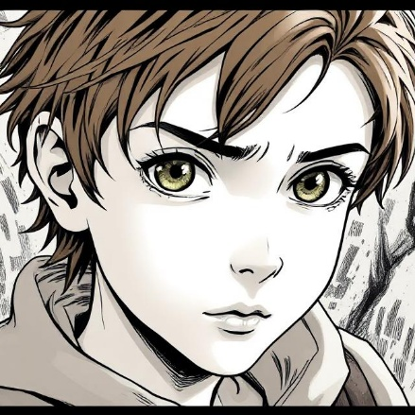

The second generator I used was magic studio. It has no options and the image generated far from my expectation. The image generated is given be

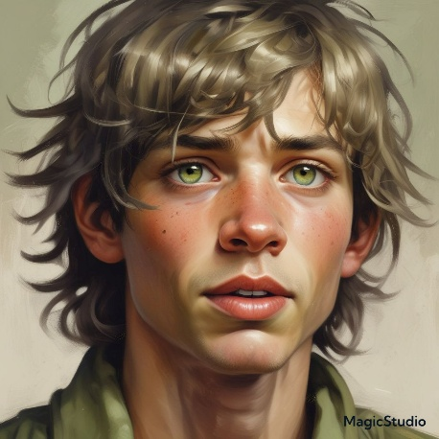

The third ai image generating software I used was of Perchase. It had many options like deepAI and also had an option of the number of images to be generated as well. The eye color generated was closer to what was on my mind but everything else was still not on the point

.